**Year 1 Knowledge Organiser: Summer 1**



**Writing**

**Writing to entertain** – Pupils will create their own poetry and narrative descriptions based on ‘Journey’.

**Writing to entertain** – Pupils will apply their learning to creating a recount based on the texts they have shared, describing their real everyday journeys to and from school, mixed with imaginary encounters.

**Writing to inform** - In this unit, pupils will create fact files to inform others about their personality, passions and achievements as well as their future aspirations

**Reading**

The class author focus for Year 1, is Michael Rosen. We are currently reading several of his texts in our class read aloud, such as We’re going on a bear hunt and chocolate cake. Our daily Phonics reading sessions focus on reading the sounds we already know, reading fluently and developing our comprehension. At the end of the day during our class read alouds this is where we focus on voice choice.

**Religion and World Views**

This unit will cover Shabbat is an important weekly celebration for many Jewish families. This unit will allow pupils to investigate the significance of artefacts, food and practices associated with the celebration from a number of different Jewish perspectives. Pupils will also have opportunities to consider what is important to them and their families.

**Art**

Pupils will be drawing from observation, printmaking using leaves and introducing secondary colours. We will also be looking at the artists:

**Frances Hatch**

**Leonardo Da Vinci**

**Geography**

Our geography topic this half term is There you are. This topic builds an understanding of where we live on the global scale; locating continents and comparing the human and physical features of an area in the UK with an area in Kenya

**Science**

In this unit our topic for the term is ‘animals’. We will be naming reptiles, fish, amphibians, birds and mammals; carnivores, herbivores, omnivores. In this unit we will also introduce pupils to the idea of classification based on some of the observable physical features.

**PHSE**

The children will be looking who helps to keep us safe.

**PE**

PE will be every Tuesday with Mr Wood, please ensure your child is bringing in the correct PE kit. They will be focusing sending and receiving.

**Music**

This half term we will continue using charanga, our unit is ‘Your imagination’. Children will be practicing and performing the song Your Imagination by Joanna Mangona and Pete Readman.

**Maths**

This half term we will be consolidating our knowledge of our number bonds to 5. We will at multiplication and division and fractions, as these are complex units we will have lots of concrete materials to help support us. Finally we will look at position and direction.

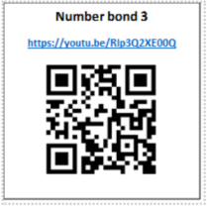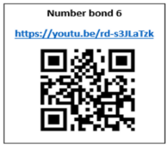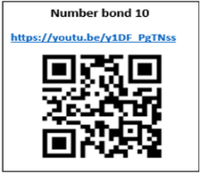

**Maths**

Please ensure that your child is practicing their number bonds at home, we practice these in class everyday, your extra support at home will secure this knowledge further. You can also watch the videos below by using the QR codes, which will help you to understand how we teach number bonds at school.

**Writing**

Writing isn’t just about telling stories or reporting on books. There are many ways your child can use words, including trying to convince others to agree with her. You can help them practice this type of writing by letting them argue with you—in writing! Choose a topic you don’t agree on, such as pocket money or bedtime. Have your child write you a letter trying to convince you to change your mind. The catch? They have to use facts, quotes and logic to back up their argument.

**Geography**

Look on google earth with your children drag and drop in lots of different places, how do the places change?

There are many videos available on the UK, here is just one: [10 Facts about the UK](https://youtu.be/Jrka9Nt-nQo?t=1)

There are many videos available on Kenya, for example:

[Geography Kids Kenya!](https://www.youtube.com/watch?v=vdPBljRitJM) (5 mins)

[Junior Jetsetters Kenya facts for kids](https://www.youtube.com/watch?v=LCX3djSzoNk) (2 mins)

**Reading**

You can support your child at home by ensuring that you are reading with them daily and logging their reading on learningwithparents.com through either a comment, picture, or voice recording! At school we have lots of books that your child can borrow and take home, these can be exchanged as many times as you would like!

**Science**

In order to support your child in science this half term, you can visit this website

https://www.bbc.co.uk/teach/class-clips-video/ks1-science-animals/znwnn9q

There are quizzes and different activities to work through.

It would be great if you could visit somewhere together with lots of different animals too, see if they can tell you what they know.

**How to help at home…**

**History**

In order to support your child in history this half term, you could go on a method of public transport together and see if your child could tell you how this method of transport has changed overtime, see if they could create a timeline of how transport has changed.